


XprESS
multi sinus dilation system
  - Information pack for health and care stakeholder to support adoption & spread
Updated March 2024

The challenge
Rhinology is the study of the nose and paranasal sinuses (a group of four paired air-filled spaces that surround the nasal cavity). Routine rhinology surgery under general anaesthetic (GA) is now faced with significant challenges which include limited theatre capacity. Delayed surgery in rhinology, particularly with regards to chronic rhinosinusitis (CRS), has been shown to have poorer surgical outcomes, a detrimental effect on quality of life and long-term negative health socio-economic effects.
(Andrews, 2021, Awake Rhinology Surgery in Response to the COVID-19 Pandemic in Europe, ORL J Otorhinolaryngol Relat Spec. 2021 Aug 31 : 1–10)
A solution
Awake rhinology surgery using the minimally invasive XprESS device under local anaesthetic (LA) provides an ideal alternative to general anaesthetic (GA). It provides a means of operating on patients in a setting alternative to currently oversubscribed main theatres, by utilising satellite facilities, while ensuring comparable surgical outcomes for patients who may otherwise have been forced to wait a long time for their procedure. “It may lead to faster recovery times and carries a lower risk of some complications”. (NICE, MTG30, p27)
Our aim and how we can help
There are 15 Health Innovation Organisations that act as a network working across England to transform lives through innovation. We identify and support the spread of innovations that improve outcomes for patients, while working with health and care stakeholders to understand and navigate barriers to adoption, improving workforce experience and clinical pathways.
We work with NHS England and NHS Improvement’s Accelerated Access Collaborative (AAC) to deliver the MedTech Funding Mandate policy. The policy aims to accelerate equitable patient access to NICE-recommended devices, diagnostics or digital products that deliver savings to the NHS; are cost saving in year; and affordable to the NHS.
This information pack holds useful information and links to resources to enable health and care stakeholders across the country to adopt this innovation with support from your local Health Innovation organisation.

In this information pack you can find:

1. List of Health Innovation contacts 4
2. Overview 5
2.1 Rhinosinusitis 5
2.2 Current Patient Pathway to Surgery 5
2.3 Functional Endoscopic Sinus Surgery (FESS) 6
2.4 XprESS multi sinus dilation system – An alternative to FESS 6
2.5 Benefits of XprESS 7
2.6 GIRFT ENT Recommended Approach to XprESS 8
3. Adoption and spread planning 8
3.1 Product Uptake Data 9
3.2 NICE - UK Prevalence of Sinusitis 9
3.3 Prevalence of Chronic Sinusitis 9
3.4 Understanding Local Prevalence 10
3.5 Hospital Episode Statistics (HES) Data 10
3.6 Clinical codes 10
4. Business case development 12
4.1 Business Case Guide 12
4.2 NICE Resource Impact Tool 12
4.3 Setting up the awake treatment room – Equipment & Costs 13
4.4 Stryker’s Budget Impact Model 13
4.5 Stryker’s Business Case Development Approach 13
4.6 Case Studies 14
4.7 Q&A – Mr Jonathan Joseph 14
5. Implementation and measurement 16
5.1 Patient Pathway 16
5.2 Proposed Clinical Pathway for XprESS 17
6. Transition to awake surgery – what is needed? 17
6.1 Measurements & Evaluation 19
7. Stryker’s Education toolkit 20
7.1 Stryker Website Product page of the XprESS Multi Sinus Dilation System 20
7.2 Stryker XprESS Multi Sinus Dilation System Procedure Brochure 20
7.3 Clinical Demonstration Videos 20
7.4 Stryker Local Anaesthesia Protocols 20
7.5 Stryker Training 21
7.6 Chronic Sinusitis Patient Brochure 21
7.7 XprESS LoProfile Product Brochure 21
8. Supporting policies 22
8.1 NICE Guidance - XprESS multi sinus dilation system for treating chronic sinusitis 22
8.2 NICE Evidence Review 22
8.3 Stryker news – XprESS NICE recommended 22
8.4 NICE guidance - Balloon catheter dilation of paranasal sinus ostia for chronic sinusitis 23
8.5 GIRFT - National Report on ENT Surgery 23
8.6 NetZero – Reducing carbon emissions 23
9. Supporting evidence 25
9.1 REMODEL larger cohort with long-term outcomes and meta-analysis of standalone balloon dilation studies 25
9.2 Awake Rhinology Surgery in Response to the COVID-19 Pandemic in Europe 26
9.3 4-year outcomes and effectiveness of balloon sinuplasty for the treatment of CRS with and without nasal polyps 27
9.4 Treatment of Chronic Rhinosinusitis (CRS) – a review of current academic literature 27
10. Health inequality considerations 29
10.1 Equalities Impact Assessment (EIA) 29
10.2 NICE Equalities Impact Assessment 30
10.3 Race 30
10.4 Awake Surgery Considerations 30
11. Stryker Contact Details 31
12. FAQs 31
13. References 33

List of Health Innovation contacts
Health innovation regional organisations | Contact
East Midlands | sophie.mason@nottingham.ac.uk
Eastern | maxine.farmer@healthinnovationeast.co.uk
Health Innovation Manchester | cath.barrow@healthinnovationmanchester.com
Health Innovation Network (South London) | iona.dewet@nhs.net
Imperial College Health Partners | logan.ryan@imperialcollegehealthpartners.com
Innovation Agency - NWC | gemma.byrne@healthinnovationnwc.nhs.uk
Kent Surrey Sussex | charlotte.roberts18@nhs.net; julian.okelly@nhs.net
North East and North Cumbria | chloe.blewitt@healthinnovationnenc.org.uk
Oxford | guy.checketts@healthinnovationoxford.org
South West | Libby.Dawe@healthinnovationsouthwest.com
UCLPartners | gareth.cairns@ucplpartners.com
Wessex | joe.sladen@hiwessex.net
West Midlands | kanwal.umar@healthinnovationwm.org
West of England | dave.evans5@nhs.net
Yorkshire and Humber | adam.smith@yhahsn.com
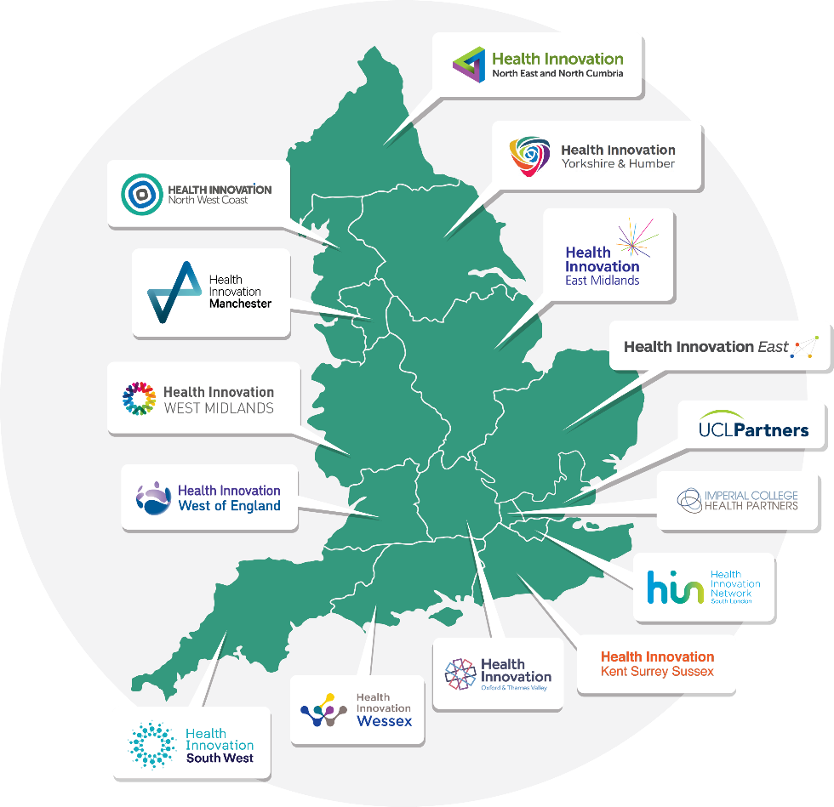

Overview

Rhinosinusitis
Rhinosinusitis, also commonly known as sinusitis and sinus infection, is defined as inflammation of the nose and paranasal sinuses. This causes an increase in mucus production and a reduction in mucus drainage if the inflamed swollen mucosa blocks the sinus ostia. Symptoms may include fever, pain, and tenderness over the affected area together with a blocked or runny nose.
Chronic rhinosinusitis is a highly prevalent condition affecting 10% of the UK adult population (ENT UK and Royal College of Surgeons, 2016). It is associated with significant reduction of quality of life, high health-care utilisation and significant absenteeism/presenteeism. Diagnosis is made by the presence of two or more persistent symptoms for at least 12 weeks, one of which should be nasal obstruction and/or nasal discharge, and/or facial pain/pressure or anosmia.

Current Patient Pathway to Surgery
ENT GIRFT’s June 2023 pathway can be found via the link here. [Also discussed in section 5.2]
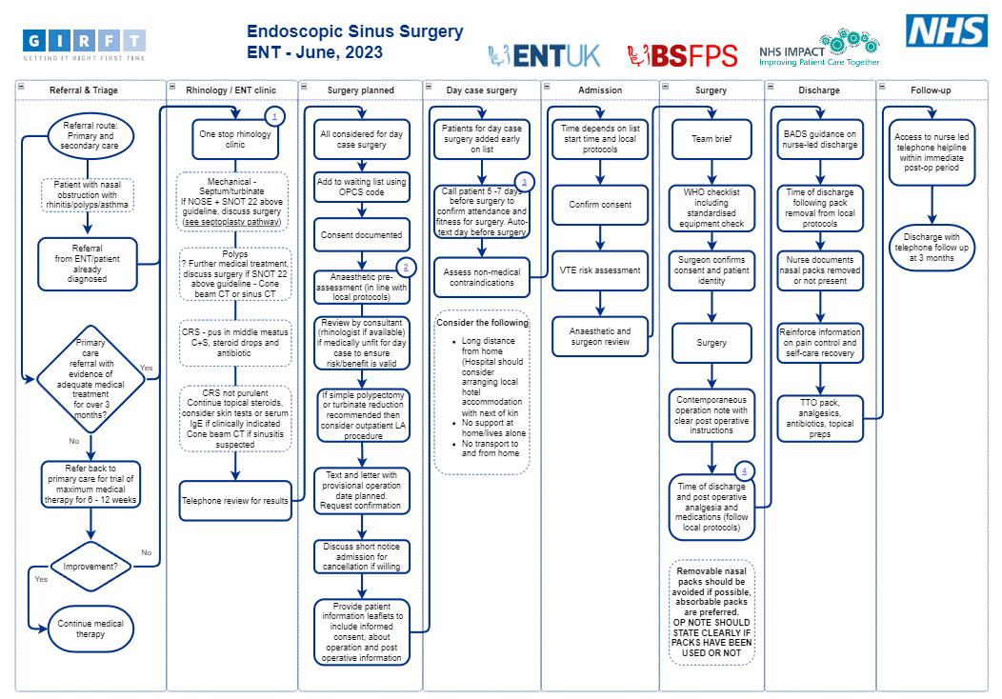

Functional Endoscopic Sinus Surgery (FESS)
The symptoms of chronic sinusitis are normally managed with decongestants, analgesics, antibiotics, topical steroids or nasal/sinus irrigation. If these interventions fail, surgical procedures to enhance drainage of secretions from the sinuses may be required. Functional Endoscopic Sinus Surgery (FESS) is the name given to these operations. Surgery is performed through the nose whilst the patient is asleep under a general anaesthetic. However, surgical procedures may be ineffective in the long term because of the development of adhesions and scarring around the ostium of the sinus. Scarring occurs less frequently if the mucosa is preserved.
Current evidence suggest that the benefits of surgery are greatest in patients undergoing surgery at an early stage in their disease (Hopkins C, Rimmer J, Lund VJ. Does time to endoscopic sinus surgery impact outcomes in Chronic Rhinosinusitis? Prospective findings from the National Comparative Audit of Surgery for Nasal Polyposis and Chronic Rhinosinusitis. Rhinology. 2015; Mar;53(1):10-7) therefore, once medical therapy has been deemed to have failed there should be no further delay in referral.
Patients undergoing surgery within 12 months of onset of symptoms that fail to respond to maximum medical therapy, achieve significantly better measured outcomes in terms on improvements in SNOT-22 (a 22 item Sino-Nasal Outcome Test) than those undergoing surgery at a later stage. Health care utilisation is significantly lower in first 2 years following surgery in patients undergoing surgical intervention compared with those having surgery at a later stage.

XprESS multi sinus dilation system – An alternative to FESS
An alternative to FESS – The XprESS multi‑sinus dilation system is a sterile, single‑use device for treating chronic sinusitis. The system comprises a balloon‑tipped device with a reshapeable end that is inserted through the nose into the maxillary, frontal, or sphenoidal sinuses.
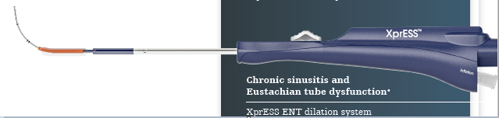

XprESS also includes an inflation syringe, bending tool and 2 extension lines to provide irrigation. The balloon is manipulated into the bony sinus outflow tracts (ostia) and inflated with saline. This reshapes and opens the ostia by displacing adjacent bone and paranasal sinus structures allowing the sinuses to drain more effectively.
The procedure is minimally invasive and can be performed whilst the patient is awake under a local anaesthetic.
Patient selection is important as it is only patients who have non-complex chronic sinusitis and are without polyps who will be applicable for XprESS. NICE’s Resource Impact Template modelled cost savings are based on 70% of FESS procedures moving to XprESS; however, the Health Innovation Networks’ support since April 2022 has found that the percentage of eligible patients is between 10 and 30%.
The product supplier (Stryker) reported a base‑case per‑patient cost of £2,679 for XprESS and £3,981 for FESS, representing an average saving of £1,302 per patient. Cost savings are based on the price of the device and moving from in-theatre to a day case setting. However, the cost of the device has increased from £800 to £950 (excluding VAT) since the NICE Guidance was initially published.

Benefits of XprESS
- A minimally invasive alternative to functional endoscopic sinus surgery (FESS), offering equivalent efficacy and minimal acute inflammation while preserving more sinus tissue and mucosa.
- Reduction in risks associated with general anaesthetic and fewer staff resources needed, because the procedure is done while the patient is awake and under local anaesthesia.
- Faster recovery time with less nasal bleeding and a shorter duration of pain medication (1.7 v 5 days)
- Improved patient comfort and tolerance compared with other balloon technologies because XprESS allows more control of device placement.
- Easier to use than other balloon technologies, because XprESS is based on a sinus seeker and no guidewire is needed.
- More accurate cannulation of the maximally ostium
- Reduction in theatre time compared with FESS.
- Reduction in length of stay in hospital.
- Reduction in duration of prescription pain medication
- Reduction in postoperative nasal bleeding visits
- Reduction in hospital readmissions
- Potentially fewer patients waiting 18 weeks or longer for ear, nose and throat (ENT) surgery.
- Less debridement required 0.2 v 1.0.
- Cost Savings will be dependent upon several factors and as a result of the shift of treatment from the operating theatre to an outpatient setting:
- XprESS device cost
- Surgical confidence (clinician training and experience)
- Procedure time
- Proportion of procedures undertaken in an outpatient setting using local anaesthetic
- Proportion of procedures undertaken in an operating theatre using a general anaesthetic

GIRFT ENT Recommended Approach to XprESS
Due to low patient cohorts GIRFT ENT expressed that there are risks associated with maintaining skill levels to perform the procedure safely, therefore XprESS should be performed by experienced Rhinologists. Regional hubs should be considered as this would create increased numbers of applicable patients improving the ability to retain the skills to perform the surgery.

Adoption and spread planning
Use the adoption and spread template below to define the key activities to help plan the adoption and spread of the technology.
Understand Context | Raise Awareness | Support Implementation | Understand Barriers | Share Learning
Map local stakeholders across system | Use national comms resources to engage ICS stakeholders through existing comms channels | Working closely with supplier to share implementation resources (business cases, budget impact models, etc) | Speak to key stakeholders to understand barriers and issues surrounding technology adoption | Share learning and stories with national stakeholders
Use Greenhalgh questions to structure approach and build understanding of local pathways | Meet with ICS clinical and commissioning stakeholders | Share this toolkit with key stakeholders | Escalate individual examples of non-compliance using the AAC/HIN Escalation Template | Gather and share local clinical audit or evaluation data and/or reports with national teams
Figure above and language adapted from the Health Innovation South West’s ‘Framework for Spread’, based on the Billions Institute’s Model for Unleashing

Product Uptake Data
XprESS product uptake data is available from the Health Innovation Network product lead. This information will highlight Trusts where there has been an uptake in using XprESS enabling the targeting of low uptake regions and learning from regions that have adopted it successfully.

NICE - UK Prevalence of Sinusitis
Information is limited on the UK prevalence of sinusitis, although a community-based survey estimated that 25% of the population studied were likely to have sinusitis based on paranasal morbidity scores [Sami et al, 2018].
https://cks.nice.org.uk/topics/sinusitis/background-information/prevalence/

Prevalence of Chronic Sinusitis
Further information about the prevalence of sinusitis and protected characteristics can be found in the Health Innovation East Midlands Equality Impact Analysis. Chronic sinusitis affects 1 in 10 UK adults (ENT UK and Royal College of Surgeons, 2016). The prevalence of chronic/acute rhinosinusitis increases with age and sex (female). In addition, people with the following conditions are at greater risk of developing chronic rhinosinusitis:
- Asthma
- Allergic rhinitis
- Anatomical variation or mechanical obstruction (for example, deviated nasal septum, nasal polyps, trauma, foreign body)
- Seasonal variation (more likely to occur in the early months of the year)
- Impaired ciliary motility (for example, cystic fibrosis)
- Aspirin sensitivity — there is an association between aspirin sensitivity and chronic sinusitis with nasal polyps.
- Immunocompromise — dysfunction of the immune system can be associated with chronic sinusitis.
- Genetic factors — chronic sinusitis without nasal polyps can run in families although no genetic abnormality linked to chronic sinusitis has been identified.
- Cigarette smoking — chronic sinusitis is more common in people who smoke.
- Latrogenic factors — sinus surgery can result in an increased risk of persistent sinus infection.
(Foden et al, 2013; Aring and Chan, 2016; Rosenfeld, 2016)
https://pubmed.ncbi.nlm.nih.gov/22487286/

Understanding Local Prevalence
Using HES data and the NICE resource and impact assessment tool to understand numbers of FESS procedures and therefore the patient numbers accessing FESS (in secondary care).
To understand the impact of adoption it is useful to understand the numbers of current FESS procedures being undertaken in a region. This will highlight which providers undertake the majority of these procedures and also show if there are any significant geographical gaps in service provision.
Knowing the number of FESS procedures will allow you to able to use NICE’s resource and impact tool more accurately (found in section 4). The tool allows you to input your local population numbers and make adjustments to the percentage of procedures from a given population to reflect a given locality. This adjustment will then reflect in the costs & resources released back to the provider if the devices are adopted at the percentages recommended by NICE.

Hospital Episode Statistics (HES) Data
Data coding will vary across Trusts and so any data request will require some assumptions to be made. Advice can be sought from the relevant clinical coding team, however, without guidance from each clinical domain it will have limitations:
- Some procedures will be missed by the coding algorithms used
- Different coding will likely be used in different Trusts
- No validation of the coding algorithms are planned against case notes
- Some of the procedures done will NOT be able to be replaced with the new technology due to clinical reasons
- Some of the procedures may already be using some of the new technology within some Trusts
Recommendation: Once you start working with providers re-review your data analysis with local data as this will be much more accurate.

Clinical codes
OPCS-4 is used to classify interventions and surgical procedures, while ICD-10 is used to classify diseases and other health conditions. Once the information is coded using these nationally mandated classifications, it is then used in an aggregated, non-identifiable form, to allow for statistical and epidemiological analysis, reimbursement of hospitals and planning of health and care services, this includes Hospital Episode Statistics (HES data In England).
For details on OPCS codes: https://classbrowser.nhs.uk/#/book/OPCS-4.10/volume1-cover.html
OPCS-4/ HES | Nasal Sinus Procedure
E13 /Y76.1 | Other operations on maxillary antrum - Functional endoscopic sinus surgery
E14 /Y76.1 | Operations on frontal sinus - Functional endoscopic sinus surgery
E15 /Y76.1 | Operations on sphenoid sinus - Functional endoscopic sinus surgery
E16 /Y76.1 | Other operations on frontal sinus - Functional endoscopic sinus surgery
E17 /Y76.1 | Operations on unspecified nasal sinus - Functional endoscopic sinus surgery
Y40.3 | Balloon dilation of Organ

The following codes are related to the NHS payment Schedule, NICE modelling use the HRG codes from 19/20 in their Resource Impact Tool.
HRG codes | Procedure for reimbursement on the Tariff | Outpatient  procedure (£) for 23/24 | Combined day  case /ordinary  elective spell (£) 23/24
CA27Z | Major Sinus Procedures | - | 2,313
CA28Z | Intermediate Sinus Procedures | - | 2,009
CA29Z | Minor Sinus Procedures | 154 | 1,643

Business case development

Business Case Guide
Double click image to access pdf
Stryker’s (the product supplier) “case for change” dossier provides comprehensive information to enable more specific and in-depth conversations with key decision makers, and as a starting point to show proof of health, economic and patient benefit of implementing the XprESS multi sinus dilation system. It is intended to be used to support business case development.

NICE Resource Impact Tool
https://www.nice.org.uk/guidance/mtg30/resources
Please note: the resource & impact assessment tools includes a 70% increase in use of XprESS whereas the NICE guidance documents recommends providers aim for 80%. However, the assumption of 80% relates to those adults who require surgery and an assumption that the majority of patients presenting to secondary care are non-complex, but in a study Jenks, (2017) states that "Up to two-thirds of patients presenting to secondary case with CS (chronic sinusitis have nasal polyps (so only 30% are non-polyp and therefore non-complex)”
Recommendation: To enable you to model correctly, ask local clinicians for their experiences of the proportion of complex and non-complex presentations referred to them in secondary care.
Please note costs are also based on 2020 product rates and not current market rates (details of which can be found in the FAQ section).
Simplified (amended) NICE Impact Tool
Health Innovation East Midlands have amended the resource impact tool to allow you to input known patient cohort numbers rather than using population health figures based on geographical areas. If you would like support in using this please contact Sophie Mason (Sophie.mason@nottingham.ac.uk).

Setting up the awake treatment room – Equipment & Costs
- Mini-FESS instrument set, including a smaller version of the FESS tray, used in theatre at approximately £6,000 + VAT
- Set of 3 low profile sinuscopes compatible with any stack system (0-degree, 45 degree and 70 degree) at approximately £11,000 + VAT
- Dentist style chair, cost dependent on requirements, style etc.

Stryker’s Budget Impact Model
Stryker have developed a Budget Impact Model (BIM), which they can utilise with the clinical teams to estimate the cost-savings from switching a proportion of the current provision of surgeries with FESS to XprESS from a selected NHS hospital perspective.
Key points:
- Uses the same model structure as a model submitted to the NICE
- Simulates cost-savings from a hospital perspective by populating the model using historical NHS data and allowing the user to modify these
- Applies user-modifiable assumption for the current number of surgeries with FESS and XprESS and estimates the potential cost-savings of switching a proportion of surgeries to XprESS

Stryker’s Business Case Development Approach
To ensure data modelling accuracy, please contact the relevant regional Stryker sales manager (see section 11 Stryker Contact Details) for a demonstration of the BIM and support for the development of the business case.

Case Studies
A patient case study: Kevin, aged 75, from London whose sinus blockage had caused repeated headaches was cleared by the XprESS multi sinus dilation system treatment leaving him free of pain and able to get on with life again. Read more here:

Further patient and clinician case studies are being developed.

Q&A – Mr Jonathan Joseph
Mr Jonathan Joseph, Consultant ENT/Head and Neck/Facial Plastic Surgeon, Royal National Throat, Nose and Ear Hospital at University College London Hospitals NHS Foundation trust offers XprESS as a treatment option for applicable patients. He has provided his view of using XprESS and the current ENT patient pathway:

What does your local patient pathway look like between your ENT department at University College London Hospitals and primary care in accessing XprESS?
Currently, patients are referred to our outpatient clinic when initial treatment for chronic rhinosinusitis has failed to improve symptoms. The ENT specialist will then usually begin more intensive medical treatment and consider further investigations such as allergy testing, blood tests, endoscopy and CT scanning. For those patients in whom symptoms persist, we will consider surgical treatment. I will assess the severity of their disease using a combination of symptom score, endoscopic evaluation of the nose and CT scanning. For those who have mild or moderate chronic rhinosinusitis without nasal polyps, they will be offered XprESS balloon dilation of the sinuses under local anaesthetic or light sedation. This will often be associated with more traditional endoscopic sinus surgery at the same time. I will expand more on this in question 6.
We are working more actively with community-based ENT clinics often run by GPs with specialist interest in ENT. They are able to do a lot of the initial investigation and treatment of these patients. The plan is to create a protocol whereby these clinicians can refer directly for XprESS balloon dilation. This would be a much more efficient process as long as standards are maintained.

How many patients annually are treated with XprESS? Has this changed over the years and why?
I am treating about 25 patients per year with XprESS. This number is increasing through a combination of clinician awareness of this as a treatment option and surgical ability to manage a wider range of patients using the XprESS.

Will those patients treated with XprESS ever require a FESS later?
Some patients do require a FESS later and I always make it clear that in some cases the sinus disease cannot be fully treated with the XprESS. An example is a patient with a blocked maxillary sinus which looked appropriate for treatment with XprESS. However, during the procedure there was fungal material contained within the sinus and it was not possible to remove all of the disease by this method. Subsequent traditional FESS under general anaesthetic successfully treated the problem.

How did you find the transition of performing XprESS in an awake setting and what patient benefits were derived?
It is more challenging to perform this procedure in the awake setting. The surgery needs to be much more accurate with little margin for error. An understanding of the nerve supply to the nose and sinuses is essential so that effective local anaesthetic can be delivered. I have developed my own protocol for preparing the patient and administering the local anaesthetic. There has been a learning curve for both myself as the surgeon and the nursing staff who assist me.
However, patient experience has remained high and it is rewarding to see the positive effect this treatment has on patients. The minimally invasive approach is much faster and requires only a brief recovery period. Patients can return to normal activity within a few days of the procedure.

What challenges & successes have you found with awake surgery in ENT more broadly?
Awake surgery still only makes up a very small proportion of the total number of operations in ENT. However, it is gaining a lot more interest and I have taken part in a number of debates and presentations at international meetings to discuss this method of treating patients.
Specifically in sinus surgery, I will often use a combination of traditional FESS techniques along with the balloon to achieve the best results.
One of the most effective procedures is nasal Polypectomy using a microdebrider. Many patients have undergone this operation a number of times previously so they are grateful to have it done in the awake setting. It can be just as effective as when using general anaesthetic while being much less invasive to the patient.
The other common procedure I carry out in awake patients is turbinate reduction. I generally use either Coblation or radiofrequency techniques. It is an ideal procedure with which to learn awake techniques as it is relatively straightforward to perform and does not take long. Anaesthetising the inferior turbinates is simple to achieve. Most patients benefit significantly following this procedure but many will require it to be repeated due to recurrence of the problem.
My Laryngology colleagues are building their awake surgery repertoire to include vocal cord injections and laser ablation of vocal cord lesions.
The head and neck cancer team perform many of their biopsies in the awake setting which facilitates much faster access to having the procedure done. Many of these patients have co-morbidities so avoiding a general anaesthetic is safer.
Within otology, we have had great success in performing insertion of bone anchored hearing aids under local anaesthetic. The team have progressed from carrying out 2 such procedures in a morning to being able to complete 3 or sometimes 4.

Do you have any patients’ perspectives or generally how the find the recovery post procedure?
Patients will always be able to leave the clinic within an hour of the procedure finishing. Some are able to go back to work the following day while others need to rest for 3-4 days. Some patients are nervous about having the surgery while awake. Also, I am expecting the procedure to be more complex in certain cases. In these situations, I will offer the patient light conscious sedation to relax them and ensure that the procedure can happen more smoothly.

Implementation and measurement

Patient Pathway
The patient pathway is varied and referral to surgery is frequently much longer than the recommended three months. Clinicians are uncertain about best management of patients with CRS in both primary and secondary care and practice is varied. GIRFT ENT have recently (June 2023) published a sinus surgery pathway which can be accessed on their Futures NHS site:
https://future.nhs.uk/GIRFTNational/view?objectID=30992560
Patient waits on the current surgical pathways are long, with ENT having the second lowest percentage of treatment within 18 weeks.
https://www.england.nhs.uk/statistics/statistical-work-areas/rtt-waiting-times/rtt-data-2020-21/#Mar21

Proposed Clinical Pathway for XprESS
For patients to benefit from XprESS an expedited patient pathway may be required, so that those suitable for balloon sinuplasty in an awake setting can access the procedure before their symptoms become too complex and develop polyps.

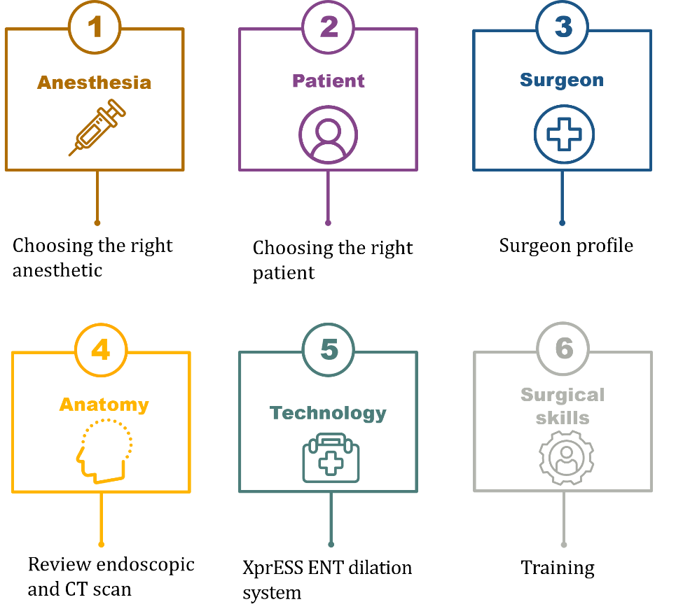
Transition to awake surgery – what is needed?
These six steps are helpful considerations in trialling awake surgery under local anaesthesia in sinusitis patients. These steps were discussed as part of a Stryker ENT webinar and virtual training from Dr Baptista (Spain) and Dr Furtado (Portugal) where they talk about their journey from doing all procedures in the OR under general anaesthesia to doing the majority of their cases under local anaesthesia. They are a recommendation and a tool to support making that transition to awake surgery.
Stryker ENT webinar: Procedures under local anaesthesia in ENT
Step 1. Anaesthesia
Please refer to the Local Anaesthesia Protocol for sinusitis that Stryker provides in this toolkit under ‘Educational toolkit’. These anaesthesia regimens were implemented by otolaryngologists while performing office procedures with the XprESS multi sinus dilation system among others. Further training can be obtained from the Stryker representative. Stryker does not recommend a specific anaesthesia regimen to be used when using XprESS. Be sure to take into consideration allergies, contraindications, and approved labelling for medication.
In the virtual training (webinar link above) Dr. Furtado will also discuss and demonstrate how to apply local anaesthesia. Many tips are discussed.
Step 2. Patient
Choose the right patient. Patients’ suitability is individually specific and should only be judged after completing a full patient history and assessment and considering all risks. Risks specific to individuals should be recorded and evaluated. Good candidates for awake surgery include patients:
- with a good understanding and willingness to have awake surgery
- who require a procedure suitable for awake surgery
- with mild or moderate disease
Step 3. Surgeon profile
Ensure that you as a surgeon are relaxed. Your behaviour and stress-level will influence the patient well-being while undergoing the procedure in the awake state. Training of the procedure using a cadaver is an essential part in getting confident. Then trial the procedure in the OR under general anaesthesia first before moving to awake surgery.
Step 4. Anatomy
Assessment of the endoscopic and the CT scan as usual. Does the patient have a favourable anatomy?
Step 5. Technology
Ensure you and your nursing staff are trained in using the XprESS multi-sinus balloon dilation system. Stryker can provide this device-training.
Other instruments or equipment you need to consider are shown in the table below.

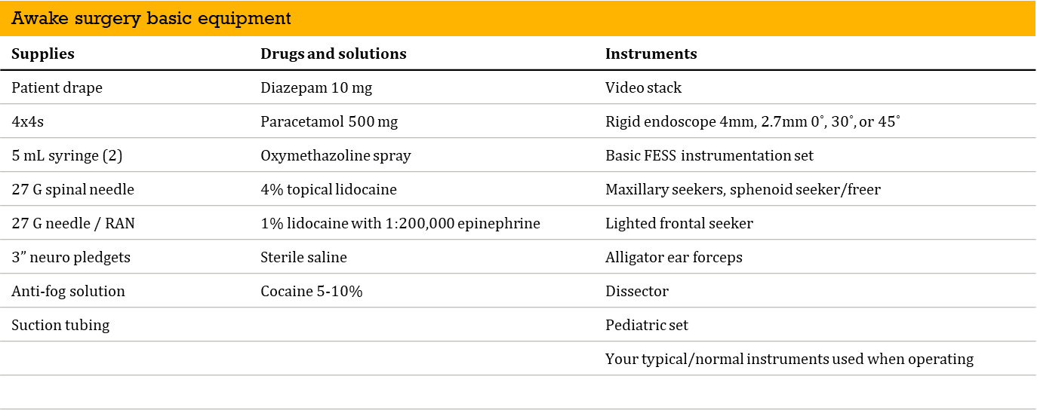

Step 6. Surgical skills
Excellence in applying local anaesthesia and the utilisation of the XprESS device will come with training and experience. Learn from other experts in the field. Stryker can set up peer-to-peer education and organises cadaver training in the UK.

Measurements & Evaluation
The following table provides a number of examples of measuring the success of implementation, this list is not exhaustive but provides a short guide for thinking through how you may want to demonstrate impact of introducing a technology to the trust:
Benefit | Measure | Data source | Assumption
Uptake as expected | Expected procedure numbers outlined in business case against numbers who received treatment | Secondary uses services (SUS)  Hospital Episode Statistics (HES)  Patient level Information & costing system (PLICs) | Clinical coding can differentiate between old & new procedures
Patients accessing treatment | Post adoption treatment rates reviewed on a regular basis | HES  PLICS | That patients are informed of the choice & that they are referred to consultant before they are complex
Patients – clinical benefits | Re-admission  Recovery rate | SUS/HES/PLICs  Post-op survey | capability to follow patients journey Ability/ capacity to follow up with patient
Cost savings | Expected saving over 3 years as reported by NICE’s resource impact tool against actual savings | NICE resource impact tool  PLICs | Ability to differentiate procedure types in clinical coding.

Stryker’s Education toolkit
Please find below the most relevant links and content to education and training resources.

Stryker Website Product page of the XprESS Multi Sinus Dilation System
https://www.stryker.com/gb/en/ent/products/xpress.html

Stryker XprESS Multi Sinus Dilation System Procedure Brochure
This document is currently in development and will be available soon

Clinical Demonstration Videos
- Dr Wells Frontal Access
- Maxillary Tip Down – Technique Video
- Sphenoid Sinus - Video

Stryker Local Anaesthesia Protocols
Double click image to access pdf

Stryker Training
Stryker ENT provides training to ENT surgeons on request and at scheduled events throughout the year. For dates, please refer to the Stryker ENT website or a Stryker representative. There is no cost for the product training provided for the safe and effective use of the XprESS balloon.
Stryker can provide this training in the following forms:
- 1:1 training with a head model, demo balloon and endoscope at a location of the clinicians choosing
- Cadaver training generally held at one of two sites in England
- Videos and tutorials
- Peer to peer visits
- Peer to peer webinars and discussions

Chronic Sinusitis Patient Brochure

Double click image to access pdf

XprESS LoProfile Product Brochure
Double click image to access pdf

Supporting policies

NICE Guidance - XprESS multi sinus dilation system for treating chronic sinusitis
https://www.nice.org.uk/guidance/mtg30
In December 2016, the National Institute for Health and Clinical Excellence (NICE) in the UK published a positive guidance for the XprESS multi sinus dilation system. Their review concluded that adoption of balloon sinus dilation with XprESS for treatment of uncomplicated chronic rhinosinusitis after medical therapy failed was supported by the clinical evidence. In their recommendation they state:
“Treatment with XprESS leads to a rapid and sustained improvement in chronic symptoms, fewer acute episodes and improved quality of life which is comparable to functional endoscopic sinus surgery (FESS).”
Furthermore, regarding the economics of balloon dilation, their recommendation stated that:
“XprESS is cost-saving compared with FESS when treatment is done using local anaesthetic in an outpatient setting.”

NICE Evidence Review
https://www.nice.org.uk/guidance/mtg30/evidence/review-decision-july-2020-pdf-8781132205

Stryker news – XprESS NICE recommended
Double click image to access pdf

NICE guidance - Balloon catheter dilation of paranasal sinus ostia for chronic sinusitis
https://www.nice.org.uk/guidance/ipg273

GIRFT - National Report on ENT Surgery
https://www.gettingitrightfirsttime.co.uk/increase-in-day-case-surgery-would-improve-care-for-ear-nose-and-throat-patients/

NetZero – Reducing carbon emissions
The ‘Delivering a NetZero National Health Service’ paper published July 2022 states:
“Anaesthetic gases used in surgery, such as desflurane, have a particularly high carbon footprint, with the emissions from one bottle equivalent to those from burning 440 kg of coal. However, low carbon alternatives exist, and are clinically appropriate in a wide variety of settings. Engagement with anaesthetists has seen a significant cut in some anaesthetic gas use since 2018, with monthly volumes of some volatiles falling by nearly 50%, saving 17 ktCO2e per year. With further clinical engagement, it could be feasible to reduce the use of desflurane to as little as 5% by volume, saving a further 23 ktCO2e per year.”
The Desflurane Reduction Project managed by the Centre for Sustainable Healthcare states: Anaesthesia as a speciality contributes up to 2% of the NHS carbon footprint or 5% of an acute hospital’s carbon footprint. The predominant source of this footprint is from anaesthetic gases, used during traditional general anaesthesia. The most harmful of these include Nitrous Oxide and Desflurane. A number of clinicians continue to use Desflurane, arguing that it is clinically superior to other commonly available anaesthetic agents in some situations. National usage of Desflurane can be monitored through the Model Health System tool.
There are tools for use to help you calculate the reduced emissions associated to moving from in-patient to day case procedures:
https://future.nhs.uk/NetworkEnvironmentSustainability/groupHome
Figures for elective in-patients stay (619kg Carbon per unit (kgCO2e)) vs day case (124kg Carbon per unit (kgCO2e))

NICE guidelines state use of the XprESS Multi-sinus Dilation device can be done in an outpatient setting using local anaesthetic where appropriate, whereas the current FESS procedure is routinely done under general anaesthesia. This change will help to reduce carbon emissions, as explained by the expert opinion below:
BMJ: “The evidence suggests that regional anaesthesia provides more effective pain relief, has fewer unpleasant side effects than general anaesthesia, shortens hospital stay, and may be preferred by patients, say the authors.
But it may also have an important environmental role that is “truly global in nature,” they add.
Unlike general anaesthesia, it doesn’t use volatile halogenated agents, such as desflurane, or nitrous oxide. These greenhouse gases, which can be retained in the atmosphere for up to 114 years, damage the earth’s ozone layer, increasing the risk of global warming and climate change.” (BMJ, 2020)
Further References to support the environmental sustainability benefits:
Inhalation anaesthetics are used in rhinological surgery, as described in the Anaesthesia for rhinological surgery paper written by I. Murdoch, P. Surda and N. Nguyen-Lu.
Remifentanil, combined with propofol or inhalational agents, is often considered first choice in anaesthesia for rhinological surgery. It reduces HR and MAP independently, dampening haemodynamic responses to surgical stimuli, can be titrated rapidly, and reduces the need for additional antihypertensive medication. It also has a short context-sensitive half-time and produces a fast postoperative recovery. (Murdoch et al, 2021)
Atmospheric science, anaesthesia, and the environment Matt Campbell, FRCA JM, J. M. Tom Pierce, FRCP FRCA FFICM BJA Education, Volume 15, Issue 4, August 2015, Pages 173–179. In this article the authors describe the atmospheric science behind global warming including the specific role of anaesthetic agents and anaesthesia practice.
Key points
• The inhalation anaesthetic agents sevoflurane isoflurane and desflurane have global warming potentials 2-3 orders of magnitude higher than CO2
• Nitrous oxide contributes significantly to global warming and ozone depletion
• 5% of the carbon footprint (CO2e) of the NHS is attributable to exhaled anaesthetic agents
• Most medical nitrous oxide liberation originates from Entonox use, including maternity use
• Reducing the environmental impact of anaesthesia, can be achieved through behaviour change

Supporting evidence
The clinical evidence for XprESS comes from published articles from:
- 2 meta-analyses
- 7 prospective, randomised, controlled trials (RCTs)
- 1 prospective, multicenter, nonrandomised, comparative study
- 8 prospective, multicenter, single-arm clinical studies
Follow-up in these studies ranged from 1 month to 2 years. The 2 meta-analyses and the REMODEL RCT provide the highest level of evidence for balloon sinus dilation compared with traditional sinus surgery (FESS).
The meta-analyses and the final long-term (1-2 year) results from the REMODEL RCT demonstrate that balloon sinus dilation improves net health outcomes long-term and is as beneficial as, or better than, the established alternative of FESS.
The final REMODEL results are consistent with results of previously published studies, thus validating the body of clinical evidence of studies on balloon dilation for the treatment of CRS.

REMODEL larger cohort with long-term outcomes and meta-analysis of standalone balloon dilation studies
https://pubmed.ncbi.nlm.nih.gov/26228589/
The publication from Chandra et al provides the final results from the REMODEL full-study cohorts and perform meta-analyses of standalone balloon sinus dilation studies, exploring long-term outcomes in a large patient sample. The final results from the REMODEL extended out to 2 years from initial treatment where results are consistent with 6-month and 12-month timelines.
The below ‘Clinical Outcomes’ document gives a 2-page top-level overview of the clinical outcomes of the META analyses including the long-term results from the REMODEL RCT.
Double click image to access pdf

Awake Rhinology Surgery in Response to the COVID-19 Pandemic in Europe
https://www.karger.com/Article/FullText/517155
The aim of this paper is to set out recommendations from an international panel of rhinologists drawn from many countries who are all experienced in safety measures and good practice in undertaking awake surgery in ENT.
These recommendations are intended to support European rhinologists and hospital managers to better utilise awake surgery capacity for rhinology during the recovery phase in the wake of the COVID-19 pandemic and these recommendations are also relevant beyond the COVID-19 pandemic.
Awake surgery was identified as a key area of need and a topic guide was used to capture panel insights on the following:
- Advantages (both to patients and healthcare) of awake surgery during the COVID-19 recovery process
- Recommendations on ‘best practice’ for awake surgery during the COVID-19 recovery process, focusing on;
- Ideal patient and surgical procedure selection
- Patient consent with COVID-19
- Procedural room and standard operating procedures (SOP) for awake surgery
- COVID-19 infection prevention control (IPC) measures, AGP risk, and PPE
- Best practice workflow management
- Teaching and training
The panel also considered available industry equipment for ENT surgeons engaging in surgery under local anaesthesia.

4-year outcomes and effectiveness of balloon sinuplasty for the treatment of CRS with and without nasal polyps
https://pubmed.ncbi.nlm.nih.gov/33202329/
Aim: The aim of this study by Castro et al, was to evaluate the 4-year outcomes and effectiveness of balloon sinuplasty in the treatment of chronic rhinosinusitis (CRS). Data was collected from 82 patients with chronic rhinosinusitis without nasal polyps (CRSsNP) and from 28 patients with nasal polyps (CRSwNP).
Results: Local anaesthesia procedures were performed in 45.5% of the patients. Significant improvements were recorded at all time points in the patient's symptom score, nasal endoscopy scores and imaging scores.
Conclusion: Balloon sinuplasty appears to be safe and effective for the treatment of CRS with great long-term outcomes.

Treatment of Chronic Rhinosinusitis (CRS) – a review of current academic literature
Chronic rhinosinusitis: a qualitative study of patient views and experiences of current management in primary and secondary care paper (Vennik et al, 2019)
[Patients views expressed in this paper cite] secondary care consultations can appear rushed, and patients would like specialists to take a more ‘holistic’ approach to their management. Surgery is often considered a temporary solution, appropriate when medical options have been explored.
Participants with nasal polyps described a good understanding of what surgery was trying to achieve; however, participants without polyps were less likely to understand the purpose of sinus surgery.
Patients in this study also described depression and anxiety associated with their sinonasal symptoms and the impact on their daily lives.

Antibiotic usage in chronic rhinosinusitis: analysis of national primary care electronic health records* (Hopkins et al, 2019)
Chronic Rhinosinusitis (CRS) is not thought to have a primarily infectious aetiology; instead CRS is largely characterised by mucosal inflammation. Systemic antibiotics, therefore, probably have little role as antimicrobials in CRS management, with the exception of treating some acute exacerbations; NICE guidelines recommend withholding antibiotics in the majority of cases of uncomplicated ARS. The European Position Paper on Rhinosinusitis and Nasal Polyps (EPOS) published treatment guidelines and a research strategy for CRS, emphasising where limited evidence restricts care (5), but there are currently no NICE guidelines for managing patients with CRS.
While the majority of patients with a definite diagnosis of CRS did not receive an antibiotic prescription, there remains a high level of repeat antibiotic prescribing; in particular, nearly 1 in 10 patients received more than 5 prescriptions for antibiotics for CRS. Nearly 1 in 2 patients who received a macrolide antibiotic prescription were given a prolonged course of greater than 2 weeks. Use of antibiotics in patients with CRS in primary care appears to be an important potential target for antimicrobial stewardship that has been so far overlooked.
Based on current evidence and guidelines, antibiotics are not routinely recommended for the treatment of CRS, and even in the setting of acute exacerbations, their value remains unclear.

Socioeconomic, comorbidity, lifestyle, and quality of life comparisons between chronic rhinosinusitis phenotypes (Philpot et al, 2021)
Patients with CRSwNP (with polyps) experience higher rates of asthma and lower rates of URTIs; patients with CRSsNP (no polyps) have worse body pain scores. Otherwise, there are no demonstrable significant socioeconomic, comorbidity, lifestyle, or quality of life differences between the two phenotypes.
A case-control study of medical, psychological and socioeconomic factors influencing the severity of Chronic Rhinosinusitis (Philpot et al, 2015)
Chronic Rhinosinusitis (CRS) is associated with significant impairment in quality of life and with certain medical co-morbidities. In contrast to other common ENT disorders, no socioeconomic differences were found between patients and controls in this study.

The burden of revision sinonasal surgery in the UK—data from the Chronic Rhinosinusitis Epidemiology Study (CRES): a cross-sectional study (Philpot et al, 2014)
This study demonstrated that there is a high burden of both primary and revision surgery in patients with CRS, worst in those with AFRS and least in those with CRSsNPs (no polyps). The burden of revision surgery appears unchanged in the decade since the Sinonasal Audit.
It is not clear at this time whether the high revision rates seen in CRSwNPs (with polyps) simply reflect the chronic nature of the condition and the limitations of current medical management, or whether there are operative variables that may be improved in order to reduce the ongoing burden of revision.

Health inequality considerations

Equalities Impact Assessment (EIA)
Health Innovation East Midlands (previously known as EMAHSN) have completed this EIA for the XprESS multi sinus dilation system and it has been reviewed by their Equalities People Panel.

NICE Equalities Impact Assessment
https://www.nice.org.uk/guidance/mtg30/history
No equality issues were identified.

Race
No equality issues were identified regarding race in the NICE equality impact assessment (EIA).
There is no published research in the UK about chronic rhinosinusitis in relation to race and treatment. Furthermore, there are some studies (2012) carried out in the United States, which highlighted that chronic sinusitis was a major health condition for all ethnic minority groups in the US and accounted for sizable hospital visits.
- 90% of cohort studies did not provide details of race/ethnicity for elective endoscopic sinus surgery.
- Prospective cohort studies indicated that minority surgical patients accounted for 18%, when compared with the national census estimates at the time (35%).

Awake Surgery Considerations
Before recommending awake surgery, consider the safety and practicalities of performing the procedure under local anaesthetic (LA), including:
- Ensuring local and national COVID-19 guidelines are adhered to ensure the safety of the patient and healthcare professionals.
- The overall procedure time and the patient’s ability to remain comfortable throughout.
- The level of discomfort the procedure will generate and whether this is appropriate for LA.
- The level of vascular control required and the risk of bleeding.
- The possible need for judicious use of electrocautery and the suitability of this for awake surgery
- The surgeon’s ability to effectively communicate with the patient throughout the procedure.
- The surgeon’s confidence to effectively perform the procedure with the patient being awake.
- Patients’ suitability is individually specific and should only be judged after completing a full patient history and assessment and considering all risks. Risks specific to individuals should be recorded and evaluated. Good candidates for awake surgery include patients:
  - mild or moderate disease
Caution should be taken when recommending awake surgery in patients:
- under 16
- with pregnancy or suspected pregnancy
- with an inability to participate in an informed consenting process
- with an inability to communicate clearly
- where there is advanced disease
- with a history of sensitivity or allergy to LA medication
- with unsuitable anatomical features, such as severely deviated septum
- with current or a recent COVID-19 positive result or symptoms
Special care should be taken when considering patients with high risk of bleeding (such as anticoagulation) or comorbidities. Awake rhinology surgery is sometimes a safer option where patients are at higher risk of bleeding or at a higher risk of complications from a GA, such as, for example obstructive sleep apnea (OSA), chronic obstructive pulmonary disease (COPD) and obesity.
(Andrews, 2021, Awake Rhinology Surgery in Response to the COVID-19 Pandemic in Europe, ORL J Otorhinolaryngol Relat Spec. 2021 Aug 31 : 1–10)

Stryker Contact Details

FAQs
What is XprESS multi sinus dilation (XprESS) System?
The XprESS multi sinus dilation system (XprESS, Entellus Medical) is a sterile, single-use device for treating chronic sinusitis.

What components make up the XprESS?
The system comprises a balloon-tipped device with a reshapeable end that is inserted through the nose into the maxillary, frontal or sphenoidal sinuses. XprESS also includes an inflation syringe, bending tool and 2 extension lines to provide irrigation.

How does it work?
The balloon is manipulated into the bony sinus outflow tracts (ostia) and inflated with saline. This reshapes and opens the ostia by displacing adjacent bone and paranasal sinus structures allowing the sinuses to drain more effectively.

What will the XprESS multi sinus dilation System replace?
Traditional functional endoscopic sinus surgery (FESS).

What are the key patient benefits of XprESS multi sinus dilation System over current practice (FESS)?
Comfortable procedure, quick recovery time, limited post-op bleeding and need for pain medication, reduced absenteeism.

What are the cost benefits?
The study found a potential cost saving when XprESS is used under general anaesthesia and more substantial savings when procedures with XprESS are done under local anaesthesia, compared to the costs of using FESS under general anaesthesia.
Using national pricing estimates, Stryker prepared a functional Business Impact Model. Please contact your Stryker Representative directly for more information or to explore the Business Impact Model.

What is the clinical evidence which NICE have used to make their recommendations?
REMODEL - (Cutler et al. 2013, Bikhazi et al. 2014, Chandra at al. 2016)
The XprESS Multi-Sinus Study (Gould et al. 2016)
The XprESS registry (Brodner et al. 2013)
The XprESS Maxillary Pilot Study (Gould et al. 2012)
The RELIEF study (Levine et al. 2013)

NICE Evidence review: https://www.nice.org.uk/guidance/mtg30/evidence/review-decision-july-2020-pdf-8781132205

Are there any other similar devices on the market?
There are several balloon dilation systems available and commonly used in the US. In the UK market, only Medtronic is marketing a sinus dilation balloon called NuVent. NuVent is different from XprESS because this device features rigid balloon sinus seekers pre-calibrated for surgical navigation with the Medtronic navigation unit.
Medtronic - https://www.medtronic.com/us-en/healthcare-professionals/products/ear-nose-throat/balloon-sinus-dilation/nuvent-em-balloon-sinus-dilation-system.html
Do other suppliers sell XprESS multi sinus dilation System?
No

What are the costs of XprESS multi sinus dilation System?
£950 each (excluding VAT)

What training is provided and at what cost?
There is no cost for the product training provided for the safe and effective use of the XprESS balloon. Also, Stryker ENT can provide training in the Local Anaesthesia protocol. Stryker can provide this training in the following forms:
- 1:1 training with a head model, demo balloon and endoscope at a location of the clinicians choosing
- Cadaver training generally held at one of two sites in England
- Videos and tutorials
- Peer to peer visits
- Peer to peer webinars and discussions

References
Andrews et al, 2021, Awake Rhinology Surgery in Response to the COVID-19 Pandemic in Europe, ORL J Otorhinolaryngol Relat Spec. 2021 Aug 31 : 1–10
https://www.karger.com/Article/FullText/517155
Aring A.M. and Chan, M.M. (2016) Current concepts in adult acute rhinosinusitis. American family physician 94(2), 97-105.
BMJ, 2020 https://www.bmj.com/company/newsroom/switching-from-general-to-regional-anaesthesia-may-cut-greenhouse-gas-emissions/
Campbell, M., and Pierce, T., 2015, Atmospheric science, anaesthesia, and the environment, BJA, | VOLUME 15, ISSUE 4, P173-179, AUGUST 2015 https://www.bjaed.org/article/S2058-5349(17)30142-7/fulltext#relatedArticles
European Position on Rhinosinusitis and Nasal Polyps 2020 https://www.rhinologyjournal.com/Documents/Supplements/supplement_29.pdf
Foden et al, 2013; Aring and Chan, 2016; Rosenfeld, 2016 https://cks.nice.org.uk/topics/sinusitis/references/
Foden, N., Burgess, C., Shepherd, K. et al. (2013) A guide to the management of acute rhinosinusitis in primary care: management strategy based on best evidence and recent European guidelines. British journal of general practice 63(616), 611-613.
Hopkins C, Rimmer J, Lund VJ. Does time to endoscopic sinus surgery impact outcomes in Chronic Rhinosinusitis? Prospective findings from the National Comparative Audit of Surgery for Nasal Polyposis and Chronic Rhinosinusitis. Rhinology. 2015; Mar;53(1):10-7
Jenks, M, 2017, https://link.springer.com/article/10.1007/s40258-017-0337-7
NICE Guidance, 2016, https://www.nice.org.uk/guidance/mtg30/resources/xpress-multi-sinus-dilation-system-for-treating-chronic-sinusitis-pdf-64371988593349
NICE Prevalence, https://cks.nice.org.uk/topics/sinusitis/background-information/prevalence/
NHS England, July 2022, Delivering a net zero National Health Service https://www.england.nhs.uk/greenernhs/wp-content/uploads/sites/51/2022/07/B1728-delivering-a-net-zero-nhs-july-2022.pdf
Rosenfeld, R.M. (2016) Clinical practice. Acute sinusitis in adults. New England journal of medicine 375(10), 962-970.

