
Patient Safety Incident Response Framework – Sustainability & Measures Planning Guidance
PSIRF is a culture change programme and requires long term commitment. This guidance has been created to support PSIRF sustainability planning and measures for ICBs as part of their supportive oversight role.
There are two levels of which sustainability and measurement plans should be considered, at a provider level and at a system level.
Clear narrative within the Patient Safety Incident Response Framework Policy which is then supported by activity detailed within the Patient safety Incident Reporting Plan is key to demonstrating the work being taken to embed PSIRF.
If details cannot be included within these documents then a separate dedicated document should be created alongside them or as an addendum within them.
Sustainability
There are three core elements that are required to ensure that PSIRF is continuously embedded and improved upon.
- Sustaining the culture change principles and ongoing practice of PSIRF to improve patient safety.
- Reviewing progress through measurement plans to demonstrate sustained practice is being achieved.
- Informing improvements that improve patient safety.
Most of this work is well underway but may not have been documented to demonstrate that there is a sustainability plan in place. This guidance aims to help make the implied more explicit.
Sustaining principles and practice of PSIRF is achieved through ongoing supportive oversight from the ICB alongside well embedded governance structures that ‘own’ PSIRF progress. So that any individual provider should know the current position as an organisation and as a system to be able to direct and focus activity going forward.
The following section provides guidance on how to link sustainability and measures through both the PSIRF Policy and Patient Safety Incident Reporting Plan.
Patient Safety Incident Response Framework Policy
PSIRF policies include details of the process associated to the PSIRF plan, how the priorities are set and how this will be taken forward. By adding further narrative on the commitment to regular reviews and revisions demonstrates a focus on future sustainability, organisations can do this by:
- Embedding sustainability throughout the policy or consolidate it in a dedicated section i.e. The policy outlines the working relationship between the ICB and providers, specifying the boards or committees where PSIRF will be addressed. By adding the narrative of sustainability as part of these board discussion will demonstrate the organisations ongoing commitment to PSIRF.
- Pointing to the tools used to help ongoing measures of PSIRF progress and their support within the regular reviews and include how the plan will detail evolution over time using these tools.
Patient Safety Incident Reporting Plan
The plan provides the detail of the activity typically within a year or two but with flexibility to adapt if required, as it is a live document. Sustained practice requires regular reviews of current activity including what progress has been made to date. So, if progress is not demonstrable, changes can be made to bring it back on track.
- Include a section within the plan that aligns with the sustainability commitments in the policy.
- With each new updated plan there should be a section dedicated to reviewing the previous plans stated activity. An example can be found in table 1
- At this point it would be helpful to provide a description of the current position using table 2 (maturity matrix) & image 1 (portal/radar chart).
Table 1. Review of previous plans stated activities
Activity | Review questions | Lessons learnt | Current position | Desired position
Local plans | - Are processes for local plans being followed?
Learning responses informing working groups | - Are learning responses discussed at working groups, are they informing improvements?
Peer reviews | - Have they taken place?
PSIRP Reviews | - Have they taken place?
PSIRF summits | - Have they taken place?
ICB quality committees | - Is PSIRF progress an agenda item?  - Are improvements from learning discussed?
Attendance at quality groups | - Is there a good level of attendance?  - Are new improvements being discussed?
Operational groups – sustained and informing priority areas for improvement | - Is there open discussion (psychological safe environment),  - Are providers learning & sharing?
Training PS level 1-4 | Mandatory/ monitored?
Maturity / phase score
Model Health System | Review Q&I section: NHS Impact – staff & wellbeing – outputs from staff survey which include:  ‘I am able to make improvements happen in my area of work’

Measurement – tools to provide a snapshot of the current PSIRF position as well as the future desired state
Table 2. PSIRF Maturity Matrix: The below image is an example of a PSIRF maturity matrix (created by HIEM) it is intended to be used as a tool to assess progress, it can be used to evaluate at an organisational or a system’s current position and provide direction on areas for future development.
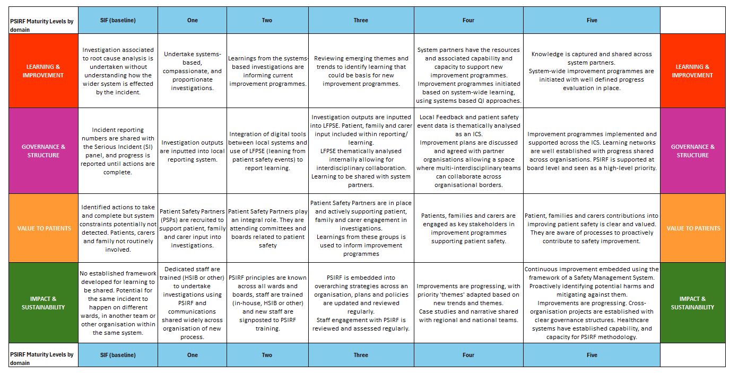
Image 1. A Portal / Radar chart: The below is an image is a portal or radar chart it can provide a quick snapshot of your ‘current position’ on the maturity matrix. This can be used as a visual to represent the above to generate discussion about strengths and areas for development going forward.
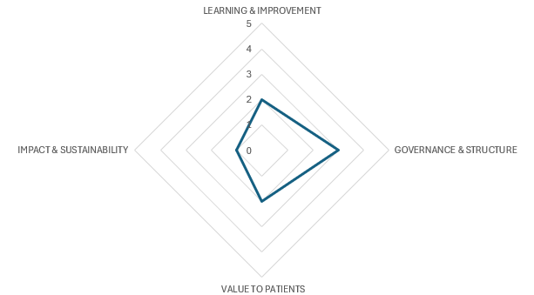

This chart shows that this example system has a well-developed governance process and structure in place and that the next focused area of work should be within the impact and sustainability domain.
Examples of using the PSIRF Maturity Matrix and the Radar Chart:
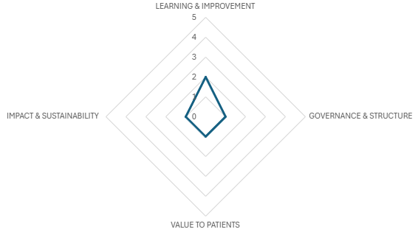
Example 1: An ICB has engaged with its providers, they have decided to use the maturity matrix to identify where activity should be focused upon in the next year. They decided to mark a domain level as complete when all providers have either reached or surpassed it. They concluded that they are at the following points within the maturity matrix and have created a Radar Chart to provide a visual snapshot.
Domain | Level
Learning & Improvement | Two
Governance & structure | One
Value to patients | One
Impact & sustainability | One
However, the position concluded is mainly due to one smaller independent provider being at a much earlier point in their PSIRF journey and doesn’t quite reflect the reality of the work undertaken by others within the system. Therefore, this approach is not right for this system and would work best for systems with less variation.
Instead, the ICB and providers decide to use averages, each provider self-assesses themselves using the maturity matrix and those numbers are used to provide a ‘system’ average, they conclude that, they are at the following levels within the maturity matrix and have created a Radar Chart to provide a visual snapshot:
Domain | Level
Learning & Improvement | Two
Governance & structure | Two
Value to patients | Three
Impact & sustainability | Three
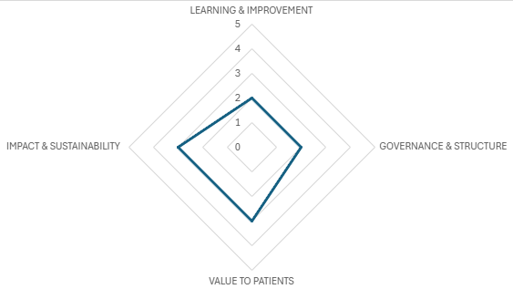
Together they have concluded that there have been challenges associated to enacting patient safety improvements and embedding the structures by which wider organisational improvements occur, therefore over the year this is where activity will be focused. They have agreed to use the maturity matrix at regular intervals within the year to show progress being made.
Image 2. Closing the loop between informing improvements and system wide improvement programmes
Finally, within the plan there should a process by which provider learning responses can support system wide improvement planning, below is process map representing of an example of what this could look like. The process focuses on system-wide processes as internal learning should follow the organisations own improvement governance processes.
