Patient Safety Partners Handbook

Containing Guidelines for
Patient Safety Partners (PSP)

Dear Patient Safety Partner,

Welcome to our team.
We really hope that you will that find your role with United Lincolnshire Hospitals NHS Trust both enjoyable and rewarding.

The purpose of this Handbook is to answer some of the questions you may have. This handbook provides guidance pertaining to your activities. It provides you with the information required to carry out your activities appropriately and safely.

If you require any additional information or assistance, please do not hesitate to approach a member of the Patient Safety Improvement Team.

CONTACT DETAILS:

 | Patient Safety Improvement Team (PSIT) | Contact Details
Name | Bridy Clark | Bridy.clark@ulh.nhs.uk
 | Steve Martin | Stephen.martin@ulh.nhs.uk
 | Samantha Tinkler | Sam.Tinkler@ulh.nhs.uk
 | Emma Barber (Admin Support) | Emma.Barber@ULH.nhs.uk

Hand Book Contents Page

About United Lincolnshire Hospitals NHS Trust 4

Our Values and Behaviours 5/8

Guidelines and Regulations 9/13

About you and your experience with us 14/15

Volunteer Rights & Responsibilities 16

Volunteer Code of Practice 17

Volunteer Confidentiality Agreement 18

To be completed with Placement Supervisor

Placement Induction Checklist 19/21

Volunteer Agreement 22

ABOUT - UNITED LINCOLNSHIRE HOSPITALS NHS TRUST

Our Trust

United Lincolnshire Hospitals Trust (ULHT) serves one of the largest geographical areas in England with a population of around 755,833 (Office of National Statistics 2018).
We provide acute and specialist clinical services to people in Lincolnshire and neighbouring counties. Lincolnshire is the second largest county in the UK. It is characterised by a dispersed population in towns, in the city of Lincoln and largely rural communities.
We have an annual income for 2020/21 of £643m. Our main contract is with NHS Lincolnshire Clinical Commissioning Group (CCG).
We provide services from three acute hospitals in Lincolnshire with a bed stock, excluding obstetrics, of 889 beds compiled as follows
Lincoln County Hospital – 509 core + 7 escalation Total cap available = 516 Pilgrim Hospital Boston – 338 core + 3 escalation Total cap available = 341
Grantham & District Hospital – 32 core + 0 escalation Total cap available = 32
The Trust also provides a wide variety of outpatient, day case and inpatient services from a range of other community hospitals operated by NHS property Services. These include:
County Hospital Louth
John Coupland Hospital, Gainsborough
Johnson Community Hospital, Spalding
Skegness and District General Hospital.
In an average year, we treat more than 140,000 accident and emergency patients, over 600,000 outpatients and over 140,000 inpatients, and deliver around 4,000 babies
The Trust provides a broad range of clinical services including community services, population-screening services, and a comprehensive range of planned and unscheduled secondary care services. A full list of services that the Trust provides can be seen under the heading of Trust Organisations Structure.
Whilst the Trust is the largest provider of elective care for NHS Lincolnshire CCG, Northern Lincolnshire and Goole NHS Foundation Trust and North West Anglia NHS Foundation Trust provide a significant share of elective care in East and South Lincolnshire respectively.

STAFF CHARTER
It sets out clear expectations of ‘what we expect to see from staff’ and what ‘staff can expect from the Trust’ as an employer, describing how together we will deliver ‘excellence in rural healthcare’ for all our patients
.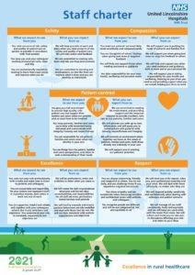
Alongside this we have also produced a personal responsibility framework, to support and underpin the charter’s values, which give examples of the behaviours we would wish to see and those we would not wish to see, to help us create a positive, caring working environment.
Based around our five core values – patient-centred, safety, compassion, respect and excellence – both our charter and personal responsibility framework were created for staff, by staff. They give us all a clear picture of what is expected of us so that we can continue to deliver safe, high quality services, day in, day out, for all our patients.

We want the charter to become embedded as part of our vision and values, as blue print for the way we want to work, and encourage everyone to adopt and live by its ethos.
Clear for all to see, the charter is displayed across our hospitals to let our patients and visitors know that we are committed to providing the very highest quality care possible.
Our Board of Directors have also pledged their support to the charter, to live by its values and lead by example.

OUR VISIONS AND VALUES

Every employee will uphold the following values:

- Putting the patient and public at the centre of what we do every day
- To lead and take responsibility, not blame others
- Working together, not undermining each other
- To fully understand problems, their cause and find solutions to those problems
- Responsive and flexible to enhance the experience of all those who use our services.
- Open and honest.

The Trust’s Behaviour Frameworks promote values and behaviours that actively support the provision of dignified care:

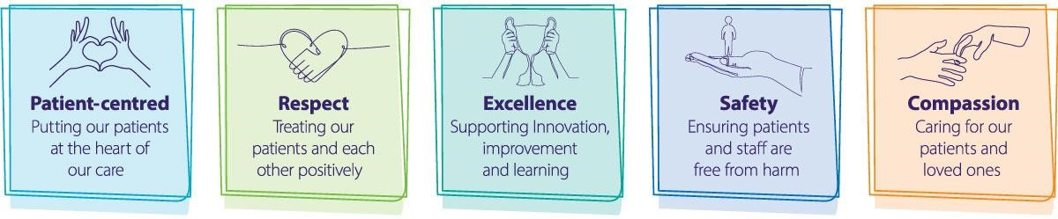
We have adopted a vision and five key values to show what we stand for, how we want to be known and how we behave.
The launch of our new Integrated Improvement Plan (IIP) in
February 2020 was a great first step in setting out our vision for the future and how we will get there.
This strategic plan, and the divisional plans which underpin it, mark an important step forward for our Trust. It identifies the key priorities for the Trust over the next five years (2020-2025), ensuring we are focused on the right things for both our patients and our staff.
Our Integrated Improvement Plan will be at the centre of all we do, supported by our Trust values.
Patient-centred- Putting patients at the heart of our care.
Safety- Ensuring patients and staff are free from harm.
Excellence- Supporting innovation, improvement and learning.
Compassion- Caring for patients and loved ones.
Respect- Treating our patients and each other positively.
Based on feedback we receive from our patients, staff and our partners we know we need to make more progress and improve rapidly in a number of areas.
Our patients and their families have told us they want to be more involved in decisions about their care and how local services are developed.
In keeping with our Trust values, our staff want to be able to come to work to deliver excellent patient care and feel respected and valued. Through working with partners we know we can do more to improve the safety of care we deliver to our patients with improved staffing numbers and a clean and safe environment.
This Integrated Improvement Plan provides the framework for us to deliver these improvements.

OUR APPROACH TO EQUALITY & DIVERSITY:

United Lincolnshire Hospitals NHS Trust recognises that everyone is different, and values the unique contribution that individual experiences, knowledge and skills make in delivering quality healthcare.
We are committed to transforming our organisational culture by actively committing to implementing the Equality Delivery System. We will continue to promote equality and challenge discrimination in all service provision, recognising and meeting the needs of the diverse communities we serve.
We will strive to provide an environment in which people want to work and to be a model employer, leading in good employment practice. We are also committed to enabling each member of staff to achieve their full potential in an environment characterised by dignity and mutual respect.
The Trust will not tolerate unlawful discrimination, victimisation, bullying or harassment based on race, ethnic or national origin, nationality, age, disability, gender, gender reassignment, sexual orientation, religion or belief, HIV status, marital status or caring responsibilities. Any action found to be in breach of any of these should be reported to your Supervisor/Line Manager/Line Manager or Voluntary Services Manager.
Dignity and Respect:

All PSP are expected to treat patients, service users and carers with courtesy, care and compassion at all times, treating each person as an individual and adopt behaviours and attitudes which promote, supports and respects privacy and dignity in accordance with the Trust Dignity policies and dignity in care pledges

Patient Safety Partner Guidelines

PSP Role Description

As a PSP you will be given a copy of a Role Description relevant to your activities. This will likely evolve as the job role matures and develops.

PSP Training:

Before starting as a PSP, you will need to have completed your induction as advised at your interview.

The majority of core learning is accessed on our eLearning platform and you will be given a guide on how to complete this at home.
However, if for any reason you cannot complete or update your induction, a member of the Patient Safety Improvement Team will be happy to help you.

Some core training will to be updated at yearly or three yearly intervals; we will let you know when your core learning is due.

Confidentiality:

PSP should regard any information concerning Service Users (Patients, Family, Carers and Visitors) as strictly confidential and must not disclose it to anyone outside the Trust. Further information is detailed in The Confidentiality Agreement at the back of this Handbook, which all PSP must sign up to.

Patient Safety Partners must:

- Take reasonable care for the health & safety of themselves and of others who may be affected by his/her acts or omissions whilst in the workplace.
- Co-operate with the Trust insofar as is necessary to enable their duty or requirement to be performed or complied with and not interfere with anything provided in the interest of health and safety.
- Report any hazards, accidents or injury immediately to staff, whilst in the workplace.

A PSP must also notify a member of the Patient Safety Improvement Team if they:

- Have an accident or ‘near miss’ whilst on duty
- Fall ill whilst on duty
- Have an illness prior to Patient Safety Partnership service

Incidents
Sometimes things happen, or almost happen to service users, staff or other people that should not happen. An Incident could be the use of inappropriate language, someone becoming angry and frightening those around them or someone leaving a ward area without staff knowing they had gone.
When something like this happens, an Incident Reporting procedure is completed by a member of staff and in serious cases an investigation in to what happened may be required. PSP may be asked to take part in an investigation if appropriate, and will be supported by a member of the patient safety improvement team.

UNIFORM AND DRESS CODE

PSP are asked to familiarise themselves with the uniform and dress code policy if the need arises to attend any of the hospitals sites.

The relevant points for this role includes the following:

Jewellery

- Jewellery may be worn, but should be discrete and in line with bare below the elbows requirements. Staff should also consider the suitability of jewellery in relation to the type of work they are engaged in, as the Trust cannot accept responsibility for any damage to jewellery caused in the normal course of an employees work
- One pair of metal smooth stud earrings is permitted, earrings with designs on are not permitted plan studs only. One earring in each earlobe.
- No additional visible body or facial (including nasal and oral) piercings may be worn other than this.

‘Bare Below the Elbows’ (BBE)

When entering any clinical areas, all staff and volunteers must roll sleeves above the elbow and remove ALL jewellery, including wrist watches, however the wearing of one plain metal band ring is permitted

Clothing (General)

The following items of clothing are unacceptable, either on the grounds of
Health & Safety, the Trust’s public image or the individual’s professional image:

- Skin tight clothing, plunging necklines, crop tops, very short skirts, shorts, frayed or torn clothing
- Jeans
- T-shirts other than provided by the Trust (Plain smart polo shirts or jersey based shirts are considered acceptable)

Personal Hygiene

All staff including volunteers should maintain a high level of personal hygiene and appearance at all times. Failure to do so will be brought to the individual’s attention by their line manager in a sensitive and private manner.

A copy of the United Lincolnshire Hospitals NHS Trust Dress Code policy can be provided on request.

Infection Control:

Please contact a member of the Patient Safety Improvement Team and do not come in if you:

- Are suffering from diarrhoea and/or vomiting. (you need to be symptom free for 48 hours before coming in).
- Have a viral infection e.g. cold, flu, sore throat or flu like symptoms
- Have a contagious infection

Alcohol hand rub is to be used by all staff before entering and exiting all hospital sites.

COVID-19

Please follow and adhere to all current United Lincolnshire Hospitals NHS Trust advice regarding the COVID-19 pandemic. Follow all guidelines,particularly with regard to wearing PPE (Face Masks) and social distancing rules.

Safeguarding Children and Vulnerable Adults:

Every individual has a right to a life free from fear, to be treated with dignity and respect and have their choices respected and not be forced to do anything against their will. Hospital staff are trained to recognise the signs of abuse and challenge them when they are institutional. PSP should escalate any concerns or suspicions to a senior member of staff.

Public Relations:

PSP may be featured in Trust public relations activities and consent will be sought from PSP prior to publication of any material in which an individual may be identified. PSP are requested not to make any statement to the media about the Trust without first consulting the Patient Safety Improvement Programme Lead.

Financial Transactions and Gifts:

PSP should not engage in any financial or cash transactions with or on behalf of Service Users (Patients, Family, Carers and Visitors). PSP should refuse to accept offers of gifts from service users and, or their carers in a manner not to cause offence and seek advice from a member of the patient safety improvement team,

Smoking:

Smoking is not allowed anywhere on NHS premises. The hospital and grounds are now completely Smoking free.

As an NHS organisation, we have a duty to protect and care for the health and wellbeing of our patients, staff and visitors. Many of the people who access our services are particularly vulnerable to the harmful effects of second hand smoke, such as pregnant women, babies, children and those with medical conditions.
We recognise that smoking is a personal choice and we do not discriminate against those who choose to do so. We are a health-promoting organisation and are committed to protecting and improving the health and wellbeing of all employees, patients and visitors.

Pregnancy:

There are certain areas within the hospital where it is inadvisable for pregnant women to enter. If you are pregnant please inform the patient safety improvement programme lead, to be adequately safeguarded.

Valuables:

The Trust cannot be held responsible for the loss of money or valuables whilst undertaking PSP duties.

Patient Safety Partner Expenses:

PSP are not expected to be out of pocket for the service that they give to the Trust.

Parking

You will not be required to pay to park whilst undertaking PSP duties. You will need to register your vehicle registration number to be added to our parking exempt list.
Once registered PSPs can park their vehicles at any of the visitor’s car parks at our hospitals.

Please remember to pay for parking as normal when you are not on official business with us.
Note :Please do not park in staff car park areas as you may receive a parking charge.

Travel/Meal expenses

Travel costs can be claimed at the current United Lincolnshire Hospitals NHS Trust rates. Expenses are normally paid directly into your bank account a few weeks after your expense claim has been presented.

ABOUT YOU AND YOUR EXPERIENCE WITH US

Wellbeing Team at United Lincolnshire Hospitals NHS Trust

How are you?
We know that caring for others in recent times, have meant that looking after ourselves is harder than ever. Yet, never has there been a more important time to consider our own health and wellbeing.
If you would like to find out more about how to improve your Wellbeing please contact our Wellbeing team at any time and they will be happy to try to help you.

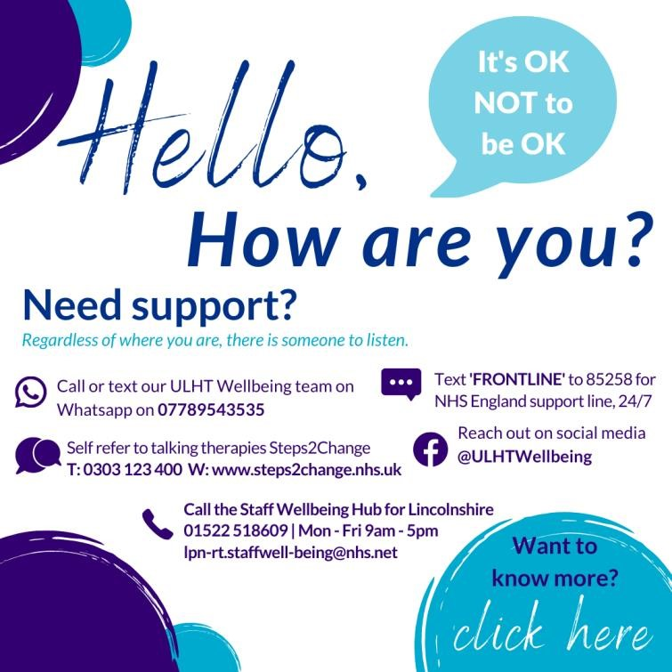

Change of Circumstances/Health Status:

Please notify the Patient Safety Improvement Team of any changes in your name, address, marital status or next of kin.

Unsuitability:

Suitability for the PSP role is assessed within 12 weeks of the starting date. A PSP who proves to be unsuitable for the placement, fails to comply with regulations or who does not attend regularly may be asked to leave at any time.

Termination of Role:

PSP is a mutual arrangement between the PSP and the Trust which can be terminated by either party at any time.

We value your feedback and if you do leave us we would be very happy to hear about your PSP experience as this will help us to continually improve the experience at United Lincolnshire Hospitals NHS Trust

*NOTE I.D badges, items issued are to be returned if you leave.

CONCERNS AND COMPLAINTS:

Who do people complain to?

Wherever possible, anyone receiving a complaint should tell someone close to the cause of the complaint for example a PSP should speak to a member of the Patient Safety Improvement Team. In many cases, it should be possible to sort the problem out straight away.
If the complaint is more involved, or if the person making the complaint wants it dealt with through a more formal procedure, they should contact the Complaints Manager/Customer Care Manager.

What if someone complains about a PSP?

If this happens, they will have the same rights as staff, which means that a PSP will be supported a member of the Patient Safety Improvement Team and will have an opportunity to have their say and receive a fair investigation.

If a PSP has a complaint about ULH as an organisation or a member of staff:

We hope that most problems can be solved informally, but if this is not the case the PSP should raise the matter formally with the Patient Safety Improvement Lead.

If the complaint is against the Voluntary Services Manager then the volunteer should raise the complaint with the Deputy Director of Clinical Govenrance.

PSP Rights & Responsibilities

Rights
- To be a valued and appreciated partner of ULH NHS Trust
- To be treated with respect and dignity. This means ULH NHS Trust will not tolerate racism, homophobia, sexism or any other form of discrimination against volunteers, staff, service users or carers
- To be listened to and taken seriously, in the same way as staff
- To have an agreed, clearly written Task Description, so volunteers know what is expected of them
- To be able to say no or negotiate tasks and responsibilities
- To receive the required induction and training
- To receive regular supervision and feedback
- To have someone to go to for support and talk with about the voluntary activity and any problems that arise
- To volunteer in safe premises with safe conditions
- To be kept informed about changes within the Trust

Responsibilities
- To treat people with respect and dignity
- To be aware of health & safety requirements e.g. fire exits
- To attend supervision, induction and training
- To be reliable and punctual, providing notice of any absences
- To share any worries or concerns about the voluntary activity
- To ask for help if needed
- To approach service users, staff and the public in a polite, friendly and cooperative manner

Code of Practice for Patient Safety Partners

I agree to:

- Always wear ID badge whilst on Trust premises, and abide by the United Lincolnshire Hospitals NHS Trust Dress code policy at all times.

- Return ID Badge when I cease to be a PSP.

- Show patients, staff, relatives and/or clients respect, confidentiality and dignity when dealing with them in line with the Trust Values and Behaviours.

- Not perform any tasks other than those agreed on the Role Description without seeking further approval.

- Inform the most senior member of staff immediately, of any concerns that I may have regarding a patient, member(s) of staff or task that I am asked to perform.

- Complete and keep up to date any PSP training relevant to my duties as instructed by the Patient Safety Improvement Lead.

- Refuse any gifts, favour or hospitality, which might be interpreted as seeking to exert undue influence to obtain preferential consideration.

I have read and understood the above code of practice

Full name of Patient Safety Partner: _______________________________________

Signed:…………………………… Date: ……………..…….

Code of Practice for Confidentially

- I hereby agree to abide by this Code of Practice for Confidentiality and undertake to keep all confidential information that I may access in the course of my voluntary duties strictly confidential.

- I understand that access to all confidential information will be on a strictly need to know basis and that I may only seek and obtain information if it is required to carry out the role for which I am a PSP.

- I will not divulge information I have obtained during the course of my time spent as a PSP in any shape or form to any other member of staff, patient or member of the general public, except in the course of professional discussions required to carry out my duties or where I perceive there to be a safeguarding risk. In all cases I will seek and be advised by my Line Manager of those categories of information which I can divulge and to whom.

- I will refer all requests for information (including those from patients, relatives, the police or press) to my Line Manager or The Trusts Communications Department.

- I understand the Trust’s requirement to protect all information both paper based, and electronic and that I must comply with the rules regarding the safe storage, transportation and distribution of patient related information in accordance with the Data Protection Act.

- I undertake not to remove any personal information relating to either patients or staff or any sensitive information from the confines of the Trust.

- I understand that I must not post any messages or have any discussions about any aspect of my PSP role on any social networking sites.

- I understand that breaches of confidentiality that occur as a result of my actions will be regarded as gross misconduct and may result in my PSP being terminated.

Full name of PSP: _______________________________________

Signed:…………………………… Date: ……………..…….

.
PSPs INDUCTION CHECKLIST - to be completed with
Line Manager.

Patient Safety Partner Name: ………………………………………………………………………………………..

Base: ……………………………………………………………………………………….

Date Commenced Patient Safety Partner Activities:…………………………………………………………………

INTRODUCTION | DATE INFORMATION GIVEN | INFORMATION GIVEN BY (Signature) | INFORMATION  RECEIVED BY  VOLUNTEER
Introduction to Area of Work – Tour of Hospitals
Introduction to colleagues

Received clear instructions on who s/he is responsible to
Been acquainted with location of dining facilities, coffee machine/kettle, library – (where available).
Introduced to the tasks to be undertaken as defined in Role Description
HEALTH & SAFETY | DATE INFORMATION GIVEN | INFORMATION GIVEN  BY (Signature) | INFORMATION  RECEIVED BY  VOLUNTEER
Location and firefighting equipment (legal requirement although volunteers not expected to use or be responsible for evacuating service users etc.)
Fire drills and alarms & location of Fire Exits/Assembly points
Security measures – doors and alarm codes (e.g. pin point alarms)
Incident forms
INFORMATION | DATE INFORMATION GIVEN | INFORMATION GIVEN  BY (Signature) | INFORMATION  RECEIVED BY  VOLUNTEER
Time sheet/Claim Forms
Meal times and arrangements
Code of dress
Procedure for informing Supervisor/Line Manager about time off/sickness absence
EXPECTED STANDARDS OF PROCEDURE | DATE INFORMATION GIVEN | INFORMATION GIVEN  BY (Signature) | INFORMATION  RECEIVED BY  VOLUNTEER
Confidentiality
Courtesy to patients/visitors/Staff/Staff Charter
Role Boundaries
Who to approach for help/information
RECEIVED INFORMATION ON:  (If applicable) | DATE INFORMATION GIVEN | INFORMATION GIVEN  BY (Signature) | INFORMATION  RECEIVED BY  VOLUNTEER
Dealing with public/media
Department rules, personal telephone calls, Mobile etiquette
Expenses & gifts (as per policy)
Communications: Team brief, notice boards, Trust newsletter, Trust website
PSP/Department meetings/Individual feedback mechanisms
Personal security

Induction Training-Elearning | DATE INFORMATION GIVEN | INFORMATION GIVEN BY (Signature) | INFORMATION  RECEIVED BY  VOLUNTEER
Equality, Diversity and Human Rights (3 years)
Infection Prevention (1 year)
Fire Safety Local Procedures ( 1 year)
Information Governance ( 1 year)
Duty of Candour ( 3 years)
Fraud Awareness ( 3 years)
Staff Charter ( 1 year)
Display screen Equipment ( 3 years)
? Safeguarding
Patient Safety Syllabus Training Level 1

I confirm that the above information has been discussed and explained to me and that I fully understand all of the information.

Patient Safety Partner Signature:

………………………………………………………

Date: ……………………

Line Manager signature: ………………………………………………..……

Date: ……………………

PSPs AGREEMENT -This document sets out the responsibilities the Trust bears to support PSP and the expectations it has of PSPs in respect of their individual job role. This is not a contract and there is no intention to create a contractual relationship between the United Lincolnshire Hospitals NHS Trust and the PSP.

United Lincolnshire Hospitals NHS Trust commits to the following:

- To provide adequate information, training and support for the PSP to be able to meet the responsibilities of his/her job role.

- To review the job role and provide feedback on performance as required.

- To respect the skills, dignity and individual needs of the PSP and where possible to respond flexibly to his/her individual requirements.

- To be receptive to any comments from the PSP regarding ways in which we might better accomplish our respective aims.

- To treat the PSP as a valued partner in meeting the Trust’s goals and fulfilment of its aims.

- To accept liability for registered PSPs whilst they undertake their approved duties. The Trust is however unable to accept responsibility for the loss of or damage to any personal property.

The PSP commits to the following:

- To perform my duties reliably and to the best of my ability and according to the role description provided

- To adhere to Trust policies and procedures, with particular regard to Health &
Safety, Equal Opportunities, Trust Values and Behaviour Framework, Confidentiality Agreement.

- To adhere to the information and guidance provided in the PSP Handbook.

- To meet time and duty commitments or to provide adequate notice so that alternative arrangements may be made, except in exceptional circumstances.

Signed (PSP): …………………………………… Date: …………………

Signed (Line Manager)……………………………… Date: ………………….

